OVERALL CSO SUSTAINABILITY: 2.9 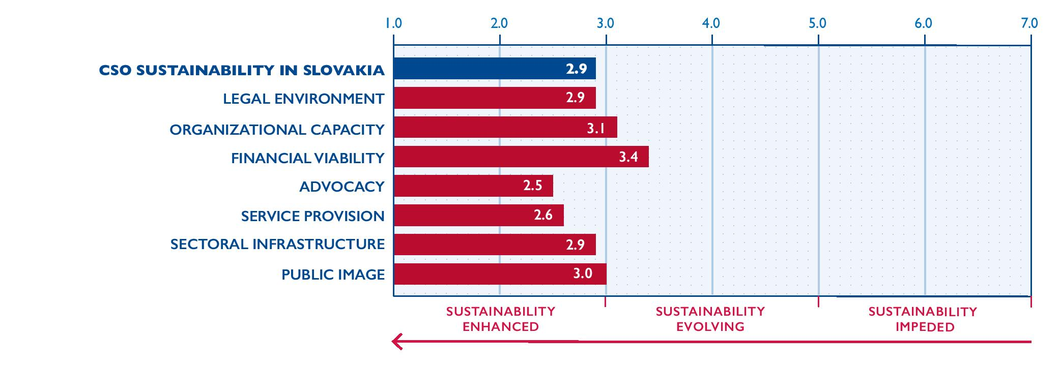
Important events in Slovakia in 2019 included the ongoing investigation into the murders of journalist Ján Kuciak and his fiancée Martina Kušnírová as well as presidential and European elections.
Thousands of people commemorated the one-year anniversary of the murders of Kuciak and Kušnírová, who were gunned down in February 2018 while Kuciak investigated organized crime and corruption among politically connected businessmen. Protests took place in thirty towns in Slovakia and more than twenty locations abroad. The protests demanded an independent investigation into the murders, resignation of the special prosecutor and the speaker of the National Council, and retirement of the former prime minister and chair of the governing Direction–Social Democracy (Smer–SD) party, Robert Fico. In September, twenty months after the murders, the prosecutor finally charged four suspects with murder and businessman Marián Kočner with ordering the murder. According to the police, Kočner sought to eliminate Kuciak because of his articles about Kočner´s dubious business activities. The investigation revealed that Kočner had corrupt links to police, prosecutors, courts, and other public authorities. Trials in the case began on January 13, 2020. High-level political corruption continued to be a major issue in 2019, especially after an anonymous user posted a recording from a 2006 secret service wiretap operation confirming business kickbacks to government officials in return for lucrative contracts.
Presidential elections were held in March 2019. In the second round of voting, Zuzana Čaputová of the non-parliamentary Progressive Slovakia party overwhelmingly defeated the Smer-SD candidate to become Slovakia’s first female president. Čaputová, a civil activist and lawyer, had previously worked with the civic association Via Iuris to promote the rule of law and fought to close a landfill in her hometown of Pezinok, for which she was awarded the Goldman Environmental Prize in 2016. Čaputová’s background in civil society was widely seen as a ray of hope for liberal democracies in the region.
Nevertheless, the polarization of Slovak society deepened in 2019. In the first round of the presidential elections, the candidate from the far-right People's Party Our Slovakia (ĽSNS) placed third with more than 14 percent of the vote. ĽSNS also won several seats in the elections for the European parliament.
In autumn 2019, with the support of Smer-SD, ĽSNS, and the Slovak National Party (SNS), the parliament adopted an amendment to the Electoral Campaign Act extending the moratorium on opinion polls from fourteen to fifty days before elections. Many saw the new rule as an infringement of freedom of expression and the public’s right to access information. President Čaputová vetoed the amendment and, after the parliament overrode her veto, challenged the amendment in the Constitutional Court. In December, the Constitutional Court blocked implementation of the amendment, ruling that the parliament’s decision to change the electoral campaign rules had been improperly adopted after the official start of campaigning for the February 2020 parliamentary elections. The court will rule on the constitutionality of the amendment in 2020. The public outcry against the amendment led to a crowdfunding initiative called 50 Days, which raised EUR 46,553 from 9,233 supporters, which will be spent on public opinion polls during the election moratorium period.
Overall CSO sustainability improved slightly in 2019. The legal environment improved as the long-awaited Act on the Register of Non-Governmental Nonprofit Organizations came into effect. CSOs’ financial viability improved with the launch of several new funding initiatives. No changes were noted in other dimensions of CSO sustainability.
According to the most recent information available from the Ministry of Interior of the Slovak Republic, there were 60,249 registered CSOs in Slovakia as of May 12, 2020. This number includes: 57,193 civic associations; 516 non-investment funds; 1,739 nonprofit organizations providing public benefit services; 147 entities with an international element; and 654 foundations.
LEGAL ENVIRONMENT: 2.9
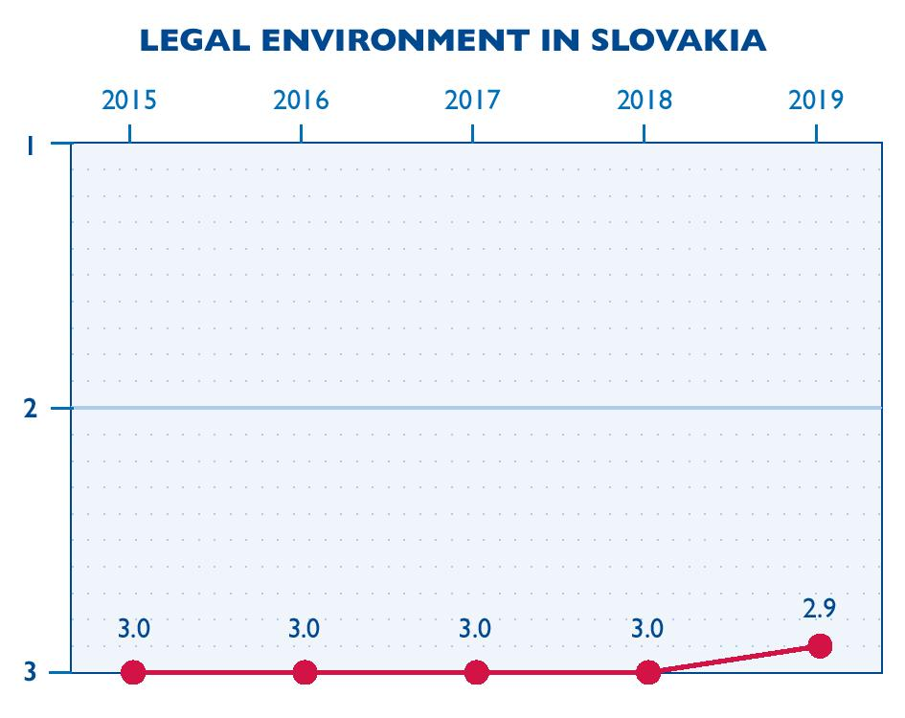
The legal environment improved slightly in 2019 as the Act on the Register of Non-Governmental Nonprofit Organizations came into effect.
The legal framework for CSOs in Slovakia remains generally favorable. CSOs may choose to register as civic associations, non-investment funds, nonprofit organizations providing public benefit services, or foundations. Each legal form has its own registration process. The laws regulating registration are generally enabling, and the process of registration is fairly simple.
On January 1, 2019, Act No. 346/2018 on the Register of Non-Governmental Nonprofit Organizations came into effect and established a single reliable, up-to-date public register of all nonprofit non-governmental organizations (NGOs). The act expands the information that applicants must provide at the time of registration and requires previously registered organizations to update their information in the register. Organizations with incomplete information (for example, about a statutory body) are not eligible for public funding. The rule is expected to improve transparency by encouraging CSOs to submit full registration data. However, at the end of 2019, the registry was not yet functional, since it was still processing information that a majority of organizations submitted at the last minute.
CSOs continued in 2019 to grapple with the European Union (EU)’s 2018 General Data Protection Regulation (GDPR), which requires organizations to protect natural persons when processing and transferring personal data. The Office of Personal Data Protection did not issue legal interpretations or recommended practices to help CSOs implement the regulation in 2019. No information is available as to whether any CSOs violated the law or were sanctioned under it or if there were any instances of the authorities misusing the law to sanction CSOs.
In 2019, ĽSNS re-introduced an amendment to the Law on Nonprofit Organizations that would create the designation “foreign agent” and establish a central register of foreign agents under the Ministry of Interior. All organizations directly or indirectly receiving foreign funds would have to register as foreign agents. The draft amendment mentioned only nonprofit organizations providing public benefit services, but ĽSNS declared its intention to widen its provisions to apply to civic associations and foundations as well. Although the amendment did not pass, the debate about it in the National Council increased anxiety among CSOs, especially after ĽSNS members of parliament suggested that domestic funds going to CSOs would be better invested directly in education or health care.
CSOs and their representatives are free to operate in accordance with the laws. The government may dissolve or restrict CSOs only for specific reasons stated in the law. CSOs may openly express criticism and take part in public protests. CSOs have the same legal right as other entities to challenge government decisions. Despite this, CSOs continued to be subject to some harassment by government officials and other political actors during the year, particularly around the presidential elections at the beginning of the year and in the run-up to the February 2020 parliamentary elections. For example, CSOs were repeatedly accused of organizing liberal plots against state and society. Ľuboš Blaha, a member of the ruling party Smer-SD, amplified this message, which was also adopted by the whole party. ĽSNS and to an extent SNS also echoed the same narrative, which was also repeated by some presidential candidates.
CSO taxation remained unchanged in 2019. Individuals and businesses supporting CSOs do not receive tax benefits. However, the Income Tax Act allows companies and individual taxpayers to assign between 0.5 and 2 percent of their owed taxes to eligible CSOs.
Some CSOs may earn income through fees and service provision, provided it is reinvested in their operations and activities. CSOs may freely engage in fundraising campaigns and accept funding from foreign sources. Regulations require that the name of a public collection differ from that of another registered collection. In 2019, two collections with different but similar names (Biela pastelka 2019 and Biela pastelka–Orava) were registered, highlighting the difficulties that emerge which an organization seeks to capitalize on a well-established name.
The Pro Bono Attorneys Program managed by the Pontis Foundation continues to provide legal services to CSOs throughout the country. CSOs may also find legal information on the website of the First Slovak Nonprofit Service Center (1.SNSC).
ORGANIZATIONAL CAPACITY: 3.1
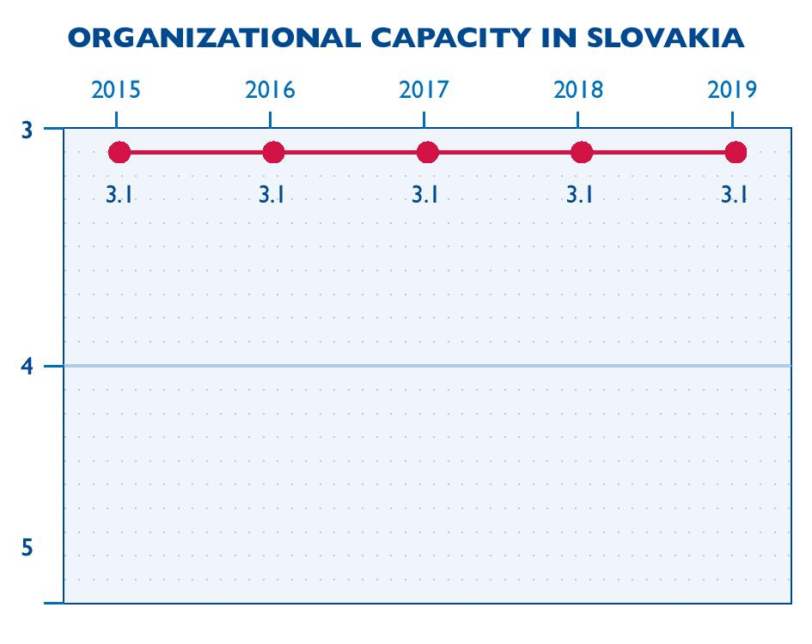
CSOs’ organizational capacity did not change in 2019.
CSOs actively seek to build relationships with their constituents, including potential supporters and volunteers. The effectiveness of these efforts is demonstrated by the fact that the number of volunteers and people making donations or assigning a portion of their taxes to CSOs grows every year.
Most organizations have clearly defined goals and visions. However, CSOs generally lack strategic plans, since they are focused mainly on obtaining funding for basic operations and do not have funds to develop long-term visions for their work. Two programs announced in 2019 focus on strengthening CSOs’ capacities and sustainability. Stronger Roots for Civil Society, implemented by the Open Society Fund (OSF) in Slovakia, will help CSOs in Slovakia, the Czech Republic, and Hungary increase their organizational and sectoral resilience and embed themselves in the communities they serve. The Active Citizens Fund (ACF), supported by the European Economic Area, is a grant program aimed at strengthening civil society, supporting active citizenship, and empowering vulnerable groups in Slovakia.
Management structures vary from organization to organization. Some CSOs establish boards of directors only to meet legal requirements, while others actively engage board members in their activities, fundraising, and strategic decision making. The law does not require CSOs to have written policies, procedures, and guidelines, although some donors require these. Some larger and well-established organizations have written codes of conduct and are transparent in their operations.
The outstanding capability of some CSO staff is evident in the fact that several civil society leaders successfully entered politics in 2018 and 2019 through municipal, parliamentary, presidential, and European elections. Their transitions were prompted mainly by the change in government and the growing threat of anti-establishment and fascist movements. In some cases, however, it was difficult for supporters to determine when these individuals stopped representing their organizations and started acting as politicians. CSOs faced certain challenges caused by the movement of individuals between the CSO sector and politics, including a struggle to identify and train qualified replacement personnel and to deal with the loss of personal networks developed by departing individuals.
CSOs’ long-term staffing capacities are limited by their inability to offer satisfactory remuneration to highly qualified professionals, especially in the Bratislava region. Most CSO employees outside of social services work on a freelance rather than contractual basis. Employment with CSOs is generally considered most suitable for young people without children. CSOs also still struggle to obtain resources to train their employees. A new law, effective January 1, 2019, stipulated that every employer with more than forty-nine employees must provide so-called recreational vouchers to all employees. The vouchers oblige employers to pay 55 percent of expenses up to EUR 275 (approximately $315) for accommodations and other services when employees vacation in the Slovak Republic. The law posed a large cost to underfinanced social-service providers, which often have a large number of staff providing services. Organizations affected by the law did not receive additional funding to meet this obligation in 2019.
Almost every CSO uses volunteers, and the number of volunteers continued to grow in 2019, especially as business professionals increasingly work as mentors and consultants. During the year, the Pontis Foundation again organized Our City (Naše Mesto), a two-day activity in which 10,000 volunteers from the private sector provide CSOs, schools, senior citizens’ centers, and other organizations with manual labor, expertise, and other services.
CSOs’ use of modern information technologies is still very limited, especially among organizations in the field of social services, which tend to devote more of their funding to salaries than to computer equipment. Most CSOs’ equipment is out-of-date, and employees tend to lack training that would enable them to use software to its full potential.
FINANCIAL VIABILITY: 3.4
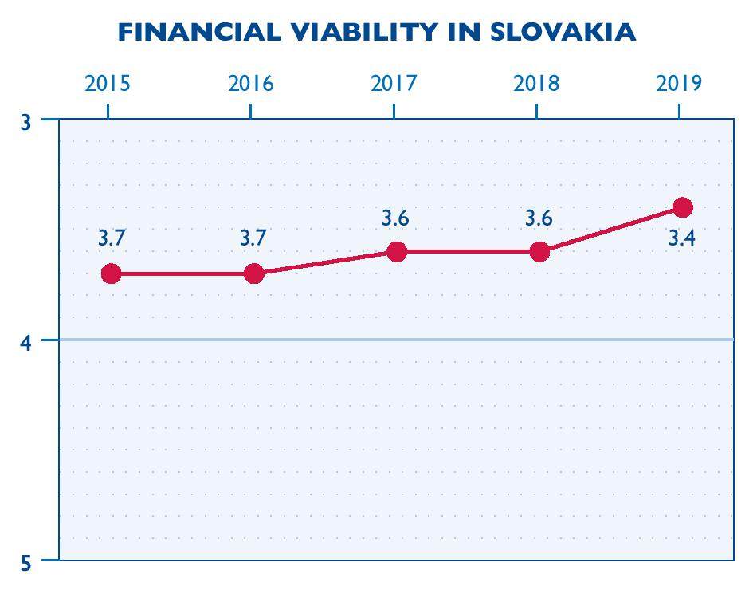
The CSO sector’s financial viability improved moderately in 2019 with the launch of several new funding initiatives.
In 2019, the ACF launched and awarded EUR 2.65 million to forty-nine projects. The ACF offers CSOs a reliable stream of funding, with a relatively light bureaucratic burden, and supports advocacy in controversial areas such as human rights, the rights of sexual minorities, and women’s reproductive rights.
CSOs also welcomed OSF’s call for proposals for the Stronger Roots for Civil Society program in 2019. The program aims to foster resiliency in individual CSOs and the sector as a whole. Thirty-five organizations in Slovakia each received EUR 30,000, with grants awarded in January 2020. Grantees also receive mentoring and consultations. Twelve organizations in the Czech Republic and twelve in Hungary received similar awards. In addition, a new law establishing a charity lottery took effect on March 1, 2019, although no lottery was organized in 2019.
EU grant schemes managed by the Slovak government continued to be problematic in 2019. CSO complaints include excessive red tape, unprofessional attitudes on the part of public officials, failure to meet deadlines, and lack of communication. Under the Operational Program Effective Public Administration (OP EPA) implemented by the Ministry of Interior, which last issued a call for proposals in 2018, for example, several organizations were forced to wait for payments for grants approved in 2018 for more than one year. As these were larger organizations, they were able to cope with delays in payment. However, many CSOs sought other sources of funding because of the bureaucratic burden, complicated design of calls for proposals, and long delays in the receipt of project approvals. This situation has led to an overall decrease in the allocation of EU funds. By the end of 2019, for example, only 26 percent of the funding available under the OP EPA administration had been used.
Several other issues with government funding for CSOs arose in 2019. The minister of culture, who is from Smer–SD, did not award grants for cultural events organized by the lesbian, gay, bisexual, transsexual, and intersex (LGBTI) community in 2019, although the events had received grants for several years and the 2019 expert panel awarded the proposals high marks and approved several grants. After a change in personnel at the government’s Office of the Plenipotentiary for Civil Society Development, an advisory body that promotes active citizen participation, efforts to reform the CSO funding system stopped. Public authorities encourage social enterprises to establish facilities such as senior care residences, community centers, and day care centers, since EU funds are available for this purpose, but they have yet to address the question of how these facilities will be financed once EU funds are depleted.
Tax assignments reached a new high in 2019. According to the Financial Administration, tax assignments in 2019 exceeded EUR 73 million, an increase from EUR 68 million in 2018. Individual donations also increased. CSOs raised EUR 2.8 million on the crowdfunding platform ĽudiaĽuďom in 2019, a 67 percent increase over 2018 and 108 percent increase over 2017. However, crowdfunding has been successful only for specific projects and does not cover strategic CSO topics or provide support for operational costs. Because of the elections in 2019, CSOs had to compete with political parties in their fundraising efforts.
Companies have traditionally focused their support of CSOs on activities related to education, health care, culture, and the arts, but the field of environmental protection is now also growing in importance. In response to the increasing pressure of customers on companies to be value-based, a growing number of companies are demonstrating their values to the public through their corporate social responsibility and corporate philanthropy programs. According to data published in the weekly magazine Trend, a majority of companies use the opportunity to assign a percent of taxes to CSOs, with companies assigning about 90 percent of the possible amount to CSOs, with the remaining 10 percent going to the state. In the last three years, companies donated an extra EUR 50 million to the assignation tax at the expense of their own profit. Corporate foundations also directly benefit from tax assignations. In 2018, thirteen corporate foundations were among the top twenty recipients of the tax assignation, and around one-fifth of the total amount of taxes assigned benefited the sixteen largest corporate foundations in the country.
CSOs are usually funded by grants, and little information is available about their efforts to generate income. The Social Economy and Social Enterprise Act, which came into effect in 2018, has yet to show much impact, and by the end of 2019, only a few social enterprises were registered.
Well-established and bigger CSOs have financial management systems and tend to be more transparent than smaller organizations. Foundations, nonprofit organizations providing public benefit services, and non-investment funds are required to submit annual reports to the government. In addition, ministries have the right to send auditors to monitor the use of funds received through tax assignments or other public resources.
ADVOCACY: 2.5
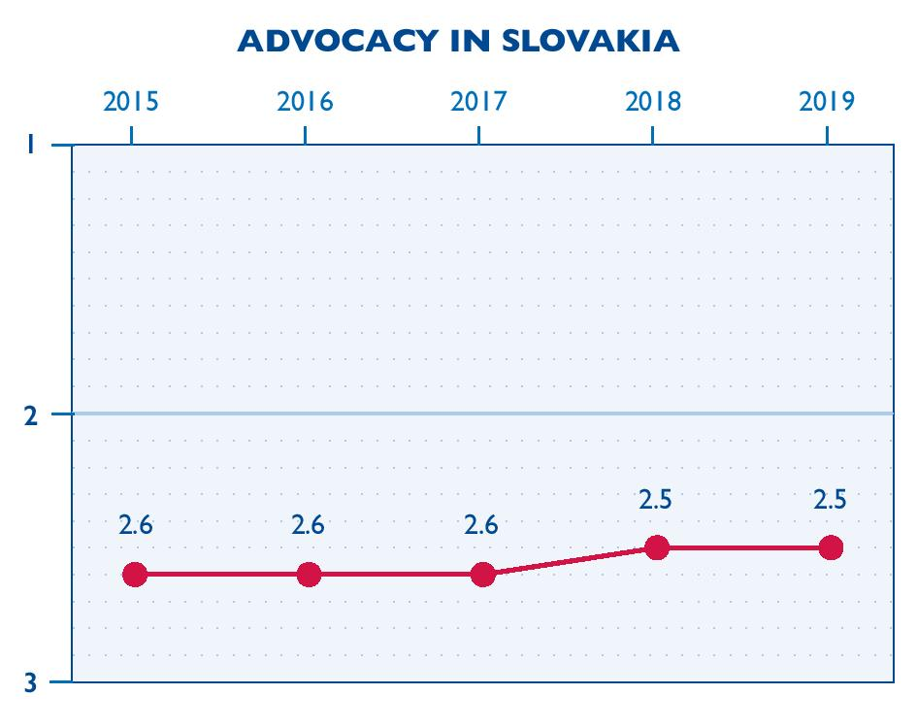
CSO advocacy did not change significantly in 2019. Despite efforts to portray CSOs as political agents trying to meddle in politics even though they were not elected, CSOs continued to engage actively in public policy issues and to build relations and cooperate with the state in areas such as environment, security, armed forces, and foreign affairs.
While CSOs established new relationships with government officials and strengthened existing ones, these relationships are still based mainly on personal contacts and trust. CSOs continued to participate in many advisory committees, but their impact is limited, since they are often outvoted by government representatives and the work of advisory committees is not tied to budgetary processes. The Government Council for CSOs continued to hold regular meetings, but many advisory committees with CSO representatives did not function properly. For example, the eight committees of the Government Council for Human Rights were completely non-functional in 2019 as an ideological war between liberals and conservatives hindered any real problem solving. The Office of the Plenipotentiary for Civil Society Development continued to support pilot schemes to develop participatory policies involving twenty-five public institutions and CSOs but did not support CSO advocacy against attacks by government representatives.
CSOs engaged in many advocacy campaigns in 2019. The Joint Civic Initiative (Spojené občianske iniciatívy) created as a response to the murder of Ján Kuciak continued to press for government accountability. In March, Rainbow Pride, a march that draws attention to bias against LGBTI communities, welcomed a record-breaking 10,000 participants. In September, several organizations declared a joint climate strike and supported students engaged on the issue. A campaign by the civic association Heart at Home encouraged Slovak citizens abroad to vote, resulting in a significant increase in the number of citizens voting from abroad. Slovak teachers demonstrated for changes to the Act on Pedagogical Employees and Specialist Employees, and pressure from Greenpeace and Friends of the Earth Slovakia, a coalition of three environmental groups, resulted in the government’s approval of a plan to develop the Upper Nitra region and cease coal mining.
Forgotten Slovakia organized a protest called Stop Fascism in front of the Supreme Court building on the day that the court should have decided whether to dissolve ĽSNS in response to a proposal submitted in May 2017. Several CSOs cooperated with the daily Sme to research the backgrounds of candidates for judgeships on the Constitutional Court. The initiative We Stand for the Constitutional Court, supported by twenty groups and more than 5,000 signatures, pushed for the votes of members of parliament on nominations to the court to be made public. Ninety-four lawyers signed and published a letter about the selection of judges entitled “We Value the Constitutional Court,” and Via Iuris launched a website, zadobruvolbu.sk, to inform the public about the activities of the Judicial Council.
While CSOs actively engaged in advocacy during the year, the efforts of some government officials to discredit CSOs’ work led to widespread frustration among CSOs and prompted many veteran leaders and organizations to become politically involved. For example, a political party participating in the 2020 parliamentary elections grew out of an initiative of Slovak farmers. When a representative of For A Decent Slovakia decided to enter politics in 2019, others cited his transition as evidence of the politicization of CSOs. Some platforms sought to cooperate with political parties on common agendas, but associations between parties and CSOs were generally polarizing. For example, when the popular environmental initiative We are the Forest promoted a candidate in the 2020 parliamentary elections, the Ministry of Environment refused to cooperate with it, claiming that it was acting as a political party, not a civic initiative. Even progressive parties or parties agreeing with the positions of civil society avoided mention of CSOs in their programs and platforms.
Several new initiatives sought to defend the sector in the run-up to the 2020 parliamentary elections. Via Iuris, Youth Council of Slovakia, and Center for Philanthropy united in an informal coalition called Voice of CSOs to coordinate efforts to prevent the shrinking of civic space and advocate on key civil society issues. Voice of CSOs actively worked to preserve the principles of participation and open governance by, for example, drafting policy proposals on civil society. OSF organized a conference on civil society, Orbis Civitates, which drew 260 participants from 125 CSOs and was attended by the president and the minister of interior. An outcome of the conference was a declaration, largely drafted by Voice of CSOs, stating CSOs’ demands in such areas as partnerships, legislation, volunteering, and funding.
SERVICE PROVISION: 2.6
CSO service provision did not change significantly in 2019. As in previous years, service provision is hampered by the government’s tendency to allocate funding to public service providers instead of to CSOs, which it categorizes as private providers.
While CSOs provide services in many fields, social services are the most dominant. The state does not take full advantage of CSOs’ potential in service provision. For example, although CSOs have the capacity to provide educational services, including civic and environmental education, some officials fear that CSO representatives will attempt to shape children’s opinions; therefore, individual schools and municipalities must express interest in CSOs’ educational services. CSOs operate various helplines, but the system for funding them is unsystematic and insufficient. As a result, the Children’s Helpline, for example, barely operates.
CSO services generally respond to community needs and donor priorities, while also filling in gaps in state service provision. Smaller CSOs and community-based organizations have personal knowledge of local needs, while larger CSOs conduct surveys or assessments to determine priority needs.
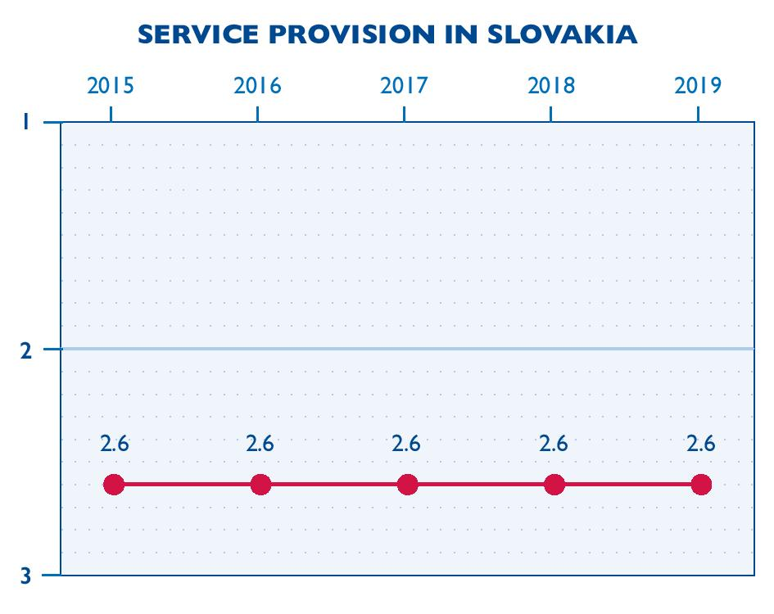
CSOs offer publications, workshops, and analysis to other CSOs, academia, businesses, religious institutions, and government bodies. CSO services are generally financed through grants and are provided without discrimination.
CSOs providing social services continued to be reluctant to innovate in their approaches. The Ministry of Labor, Social Affairs, and Family sends contradictory messages to CSOs, for example, asking them to develop more recreational services while also withholding funding. The ministry prefers to fund field and ambulance services and is closing daycare residencies. Municipalities are reluctant to pay for social services for the elderly. Some schools help pay for extra-curricular educational programs provided by CSOs.
Some CSOs recover costs by charging fees for their services. Certain services should be partly covered by municipal funding, but as such funding can be time-consuming or impossible to obtain, CSOs often offer those services for free with funding from various donors.
SECTORAL INFRASTRUCTURE: 2.9
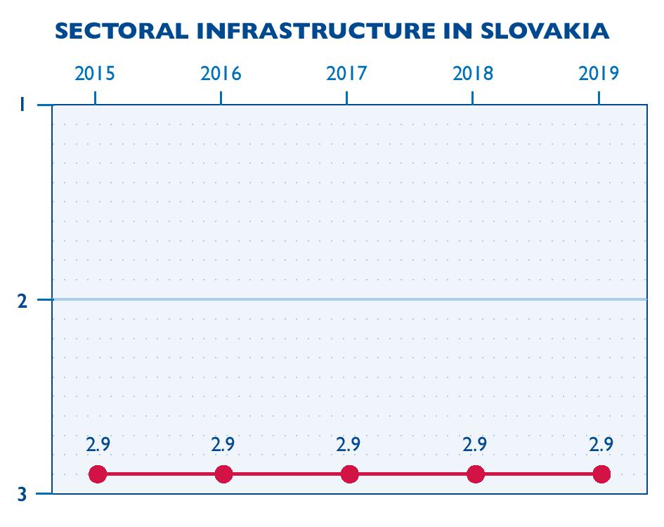
The infrastructure supporting the CSO sector did not change in 2019. Unlike most other countries in the region, Slovakia does not have intermediary support organizations (ISOs) or CSO resource centers. As a result, CSOs continue to have limited access to relevant information, technology, training, and technical assistance.
As in the previous year, CSOs formed coalitions to address hot topics, which usually fall apart or reduce their activities after a while because they lack stable human and financial resources. In 2019, Via Iuris received a grant from Civitates, a philanthropic initiative hosted by the Network of European Foundations to foster democracy and solidarity in Europe, for the Voice of CSOs coalition. Voice of CSOs had forty-five member organizations from throughout the sector in 2019. The informal platform CS Defense had more than 200 members and continued to share information to help the sector defend itself through, for example, a weekly newsletter that monitors disinformation about CSOs in the media and a Facebook page that serves as an early awareness mechanism for crucial news and information about CSOs.
Eight community foundations continue to operate in Slovakia. Using their knowledge of local conditions, these foundations raise funds from local donors to assist people and CSOs in their regions. Several foundations, such as the Pontis Foundation and Center for Philanthropy, provide grants to CSOs using the funding they obtain from tax assignations.
CSOs have access to a sufficient array of educational activities and trainings covering the majority of their needs, including time management, public speaking, accounting, fundraising, and the GDPR. Experts at several organizations, including the Pontis Foundation, Voices, Slovak Fundraising Center, and getADVANTAGE, offer training to CSOs on a pro bono basis. Maxman organizes pro bono as well as paid trainings, and Partners for Democratic Change Slovakia (PDCS) charges for its educational activities.
In 2019, the government’s Office of the Plenipotentiary for Civil Society Development conducted a large research project in preparation for developing a new strategy for the development of civil society. However, CSOs do not believe that the research was conducted in a professional manner, observing that while the methodology was well planned, focus groups were not chosen correctly and generated inaccurate data.
CSOs continue to develop partnerships with stakeholders from other sectors. CSOs have good partnerships with the business sector, some of which go beyond financial support to include the transfer of know-how and capacity building. In 2019, CSOs cooperated with academia around the protests. For example, universities freed their students to take part in the Fridays for Future Climate Strike in September. The Investigative Center of Ján Kuciak, which was established in 2019, works closely with the media and investigative journalists. CSOs develop some ad hoc partnerships with the government, but these depend largely on personal contacts, as described above.
PUBLIC IMAGE: 3.0
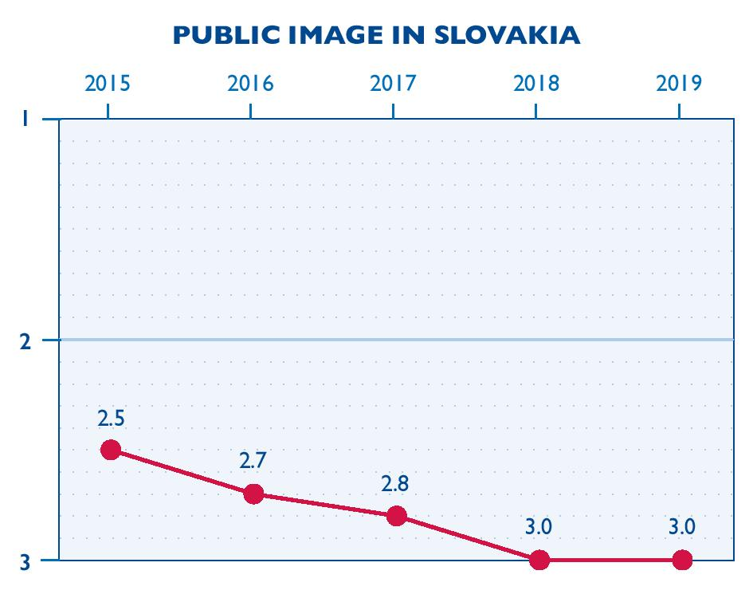
The CSO sector’s public image did not change significantly in 2019.
Alternative and conspiracy-driven media intensified their campaigns to discredit CSOs during the year, portraying CSOs as foreign agents seeking to introduce untraditional values. Some media, such as the series Political NGOs on internet radio Slobodný vysielač, systematically spread misinformation about the sector. Some attacks alleged that particular CSOs had connections to political parties, and smears propagated by conspiracy media, political extremists, and certain political parties often spread beyond CSOs to attack liberal values and democracy in general. The fact that a number of former CSO staff entered politics fueled the new narrative.
Mainstream media, on the other hand, cover large CSO events such as protests, often in a positive manner, but are generally uninterested in covering CSOs’ agendas.
The public had a positive perception of the role of advocacy and watchdog CSOs in uncovering corruption and highlighting unfair practices in government in 2019. CSOs’ activities related to the ongoing investigation of Ján Kuciak´s and Martina Kušnírová´s murders were also positively perceived. In a survey commissioned in March 2019 by the organization Globsec and conducted by Focus, almost 60 percent of respondents agreed with the statement that CSO activities are important for a democratic society, while 31 percent disagreed. Nearly half (49 percent) of respondents agreed that CSOs are often unfairly accused by the state and some media, while 37 percent disagreed. At the same time, 45 percent of respondents agreed with the statement that CSOs are often used to undermine Slovak values and should be strictly regulated by the state, while 41 percent disagreed. A public opinion poll published by Voice of CSOs in November 2019 showed that 55 percent of respondents trusted CSOs (13 percent completely and 42 percent partially), and 64 percent of respondents thought that in some areas, CSOs are better able than the state to fulfill citizen needs. Nevertheless, CSOs struggled in 2019 to engage volunteers and members in the face of the ongoing smear campaigns.
Government parties Smer-SD and SNS continued to deploy negative statements about CSOs, which improve their standing with certain segments of society. ĽSNS and the We Are Family (Sme Rodina) movement employed negative rhetoric against CSO during debates about the proposed foreign agent law. In 2019, the business sector’s perception of CSOs was unchanged, and businesses remained allies of CSOs
CSOs were more concerned with their public image in 2019 than in previous years and took active measures to counteract misinformation and misleading articles. The Center for Philanthropy, Via Iuris, and the Youth Council of Slovakia launched the website mimovladky.sk to increase awareness of the civic sector by sharing examples of good practices and civic engagement, along with information on CSOs’ activities. The website demagog.sk, run by the SGI Institute, verifies the truthfulness of statements made by politicians and other public persons. CSOs also increased their use of social media, particularly Facebook and, increasingly, Instagram. However, according to a survey conducted by 2muse, social media usage does not necessarily increase awareness about CSOs. Survey respondents noted that they were introduced to the CSOs they support via advertisements, with half of them mentioning television ads. Only 2 percent of respondents said that they got to know the CSO they support through Facebook.
As in previous years, large and well-established CSOs publish annual reports as part of their transparency efforts. CSOs generally lack codes of ethics, although some larger and well-established organizations have written codes of conduct.
Disclaimer: The opinions expressed herein are those of the panelists and other project researchers and do not necessarily reflect the views of USAID or FHI 360.

